PROJECT & PORTFOLIO II (MDV228)

**AudioPhile**

WHERE YOUR MUSIC LIVES



# 

Figure 1. Torval, M. (n.d.). Collection of vinyl records on a shelf.

Adobe Stock. https://tinyurl.com/5n6svc4v

Introduction

The music database application will help users find and save information about their favorite musician’s albums and songs. They will search by the artist’s name to view their discography in a list format. When an album is selected, the title and album cover will be displayed, and the user will have the choice to add the selection to their list of favorites. When viewing their list of favorites, they can choose to remove any of the listed albums.

Table of Contents

Mobile App Description  **3**

Example 3

Competitor #1 **4**

Competitor #2 **5**

User Stories **6**

API Information **7**

App Icon & Splash Screen **8**

Color Palette **9**

Low-Fidelity Design **10**

Low-Fidelity Digital Design **11**

High-Fidelity Final Design **12**

Usability Hub Data & Results (Low-Fidelity) **13**

Usability Hub Data & Results (High-Fidelity) **14**

Alpha Version **15**

Beta Version **16**

Images References **17**

References **18**

## 

## Mobile App Description

To me music is a friend, a tool for clearing your mind and another form of communication. What I mean by this is that whenever I feel like I need to release any type of emotion, I play a song that portrays that emotion and as the song plays, that emotion is released from my body. Music is a universal language but is subjective and can mean whatever you want or need it to. With this application users can research and save music information to be used however they would like. They can search by artist name to retrieve a list of albums and add them to a list of their favorites.

### Example

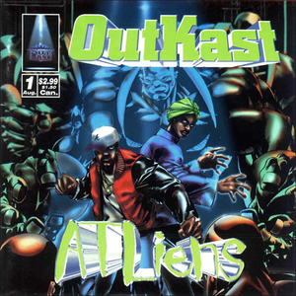

Figure 2. OutKast. (1996). *ATLiens* [CD]. LaFace Records.

**OUTKAST – ATLIENS**

**ADD TO FAVORITES**

**Competitor #1**

**Shazam** is an app that identifies songs by an audio snippet. It will identify any song in seconds. Get recommended songs and playlists to discover new music, open any song directly in Apple Music or Spotify, and share songs with friends through social media apps.

[View the iOS Version](https://apps.apple.com/us/app/shazam-music-discovery/id284993459)

[View the Android Version](https://play.google.com/store/apps/details?id=com.shazam.android&hl=en_US&gl=US)

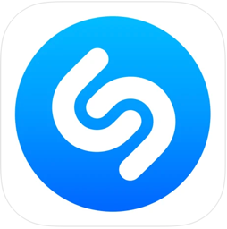

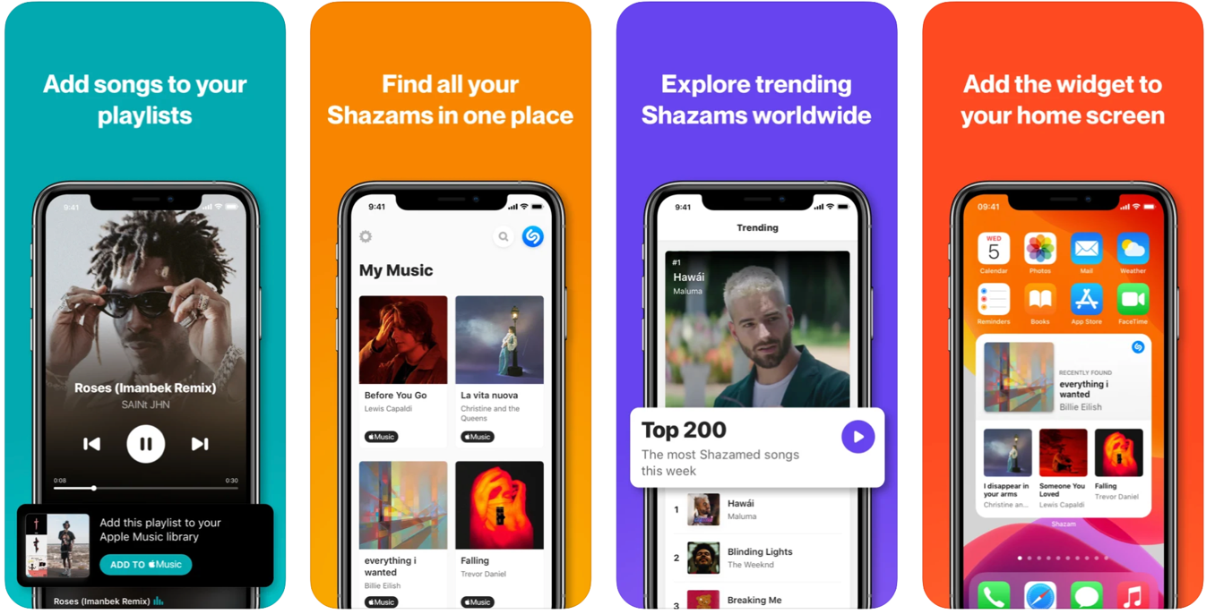

Figure 3. (2022). Shazam iOS App & Icon. Apple App Store. https://apps.apple.com/us/app/shazam-music-discovery/id284993459

## 

## Competitor #2

**Last.fm** is a music streaming app that tracks the user’s listening stats and lets them view them. Access to your last week & last year listening reports. View your personal artist, album and track charts from all-time to the last 7 days, explore your listening history, and view tag, artist, similar artist, and track information.

[View the iOS Version](https://apps.apple.com/us/app/last-fm/id1188681944)

[View the Android Version](https://play.google.com/store/apps/details?id=fm.last.android&hl=en_US&gl=US)



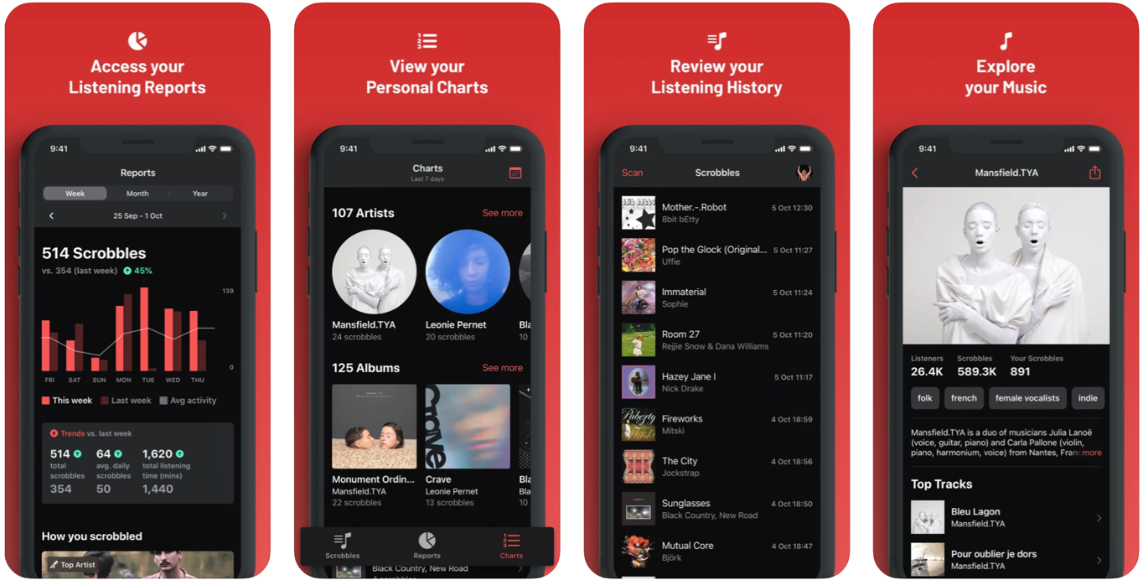Figure 4. (2022). Last.fm iOS App & Icon. Apple App Store. https://apps.apple.com/us/app/last-fm/id1188681944

## User Stories

These are user stories that will used when developing and testing the application.

* I want to **sign up** for the *app* if I am a new user.
* I want to **sign in** to the *app*.
* I want to **sign out** of the *app* when I am not using it.
* I want the **app to be** *user friendly*.
* I want the **app to look** *new* and *sleek*.
* I want to **search** for music by *artist name*.
* I want to **search** for music by *album title*.
* I want to **view** the album *details*.
* I want to **view** the album *cover art*.
* I want to be able to **add** *music to a list* of my favorites.
* I want to be able to **remove** *music from the list* of favorites.
* I want to **contact** the *app creators* with feedback and reviews.

## 

## API Information

There are many APIs that handle the data for this particular app. The API would need to have the artist’s name and discography as well as an image link for the cover art. Most of the APIs I came across have all the information about the artist and their music however, not many had the images.

Possible APIs:

* Spotify.com - <https://developer.spotify.com/documentation/web-api/>
* Musicmatch.com - <https://developer.musixmatch.com/documentation>
* Last.fm - <https://www.last.fm/api>

The required data for the application will include:

* The artist’s name
* The artist’s albums
* The album’s cover art

## App Icon & Splash Screen

## For the AudioPhile icon, I found multiple images from Adobe Stock and manipulated them into different versions of my idea of a logo. I added the app title and used different color schemes to achieve my final choice. The splash screen is variation of the icon with the title included.

## 

Figure 5. Davis, C. (2022). App Icon Variations & Splash Screens.

## Color Palette

This Application will have a 4-color palette.

* **Border Color** (Dark Gray) - #5F5F5F
* **Background Color** (Black) - #000000
* **Text Color** (White) - #FFFFFF
* **Highlight Color** (Blue) - #226FEC
* **Extra Color** (Light Gray) - #B2B2B2

Below is an example of how the final application will look:

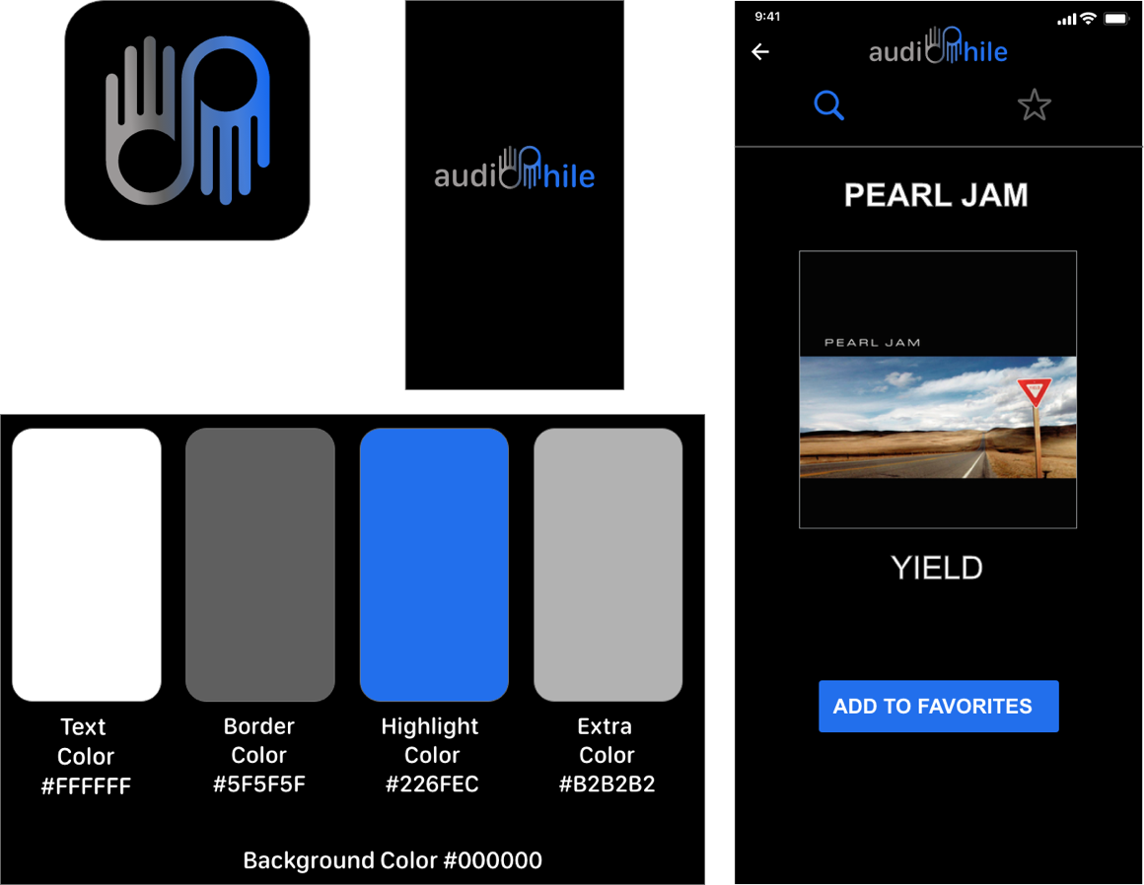

Figure 6. Davis, C. (2022). Color Palette Example. Self

## Low-Fidelity Design

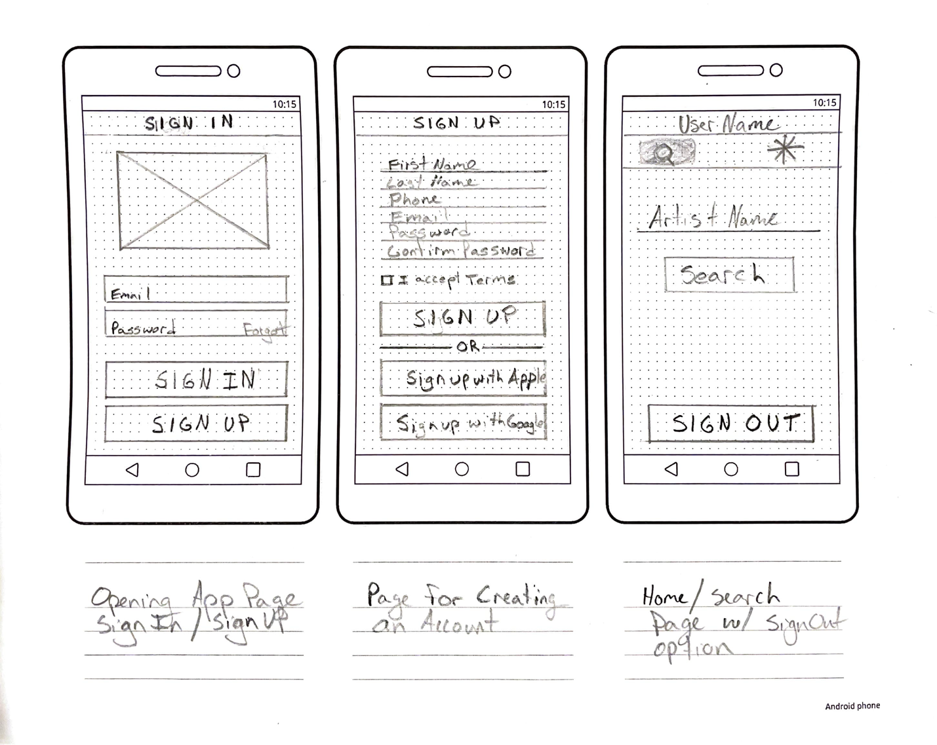

Figure 7. Davis, C. (2022). Lo-Fi Sketch 1. Self

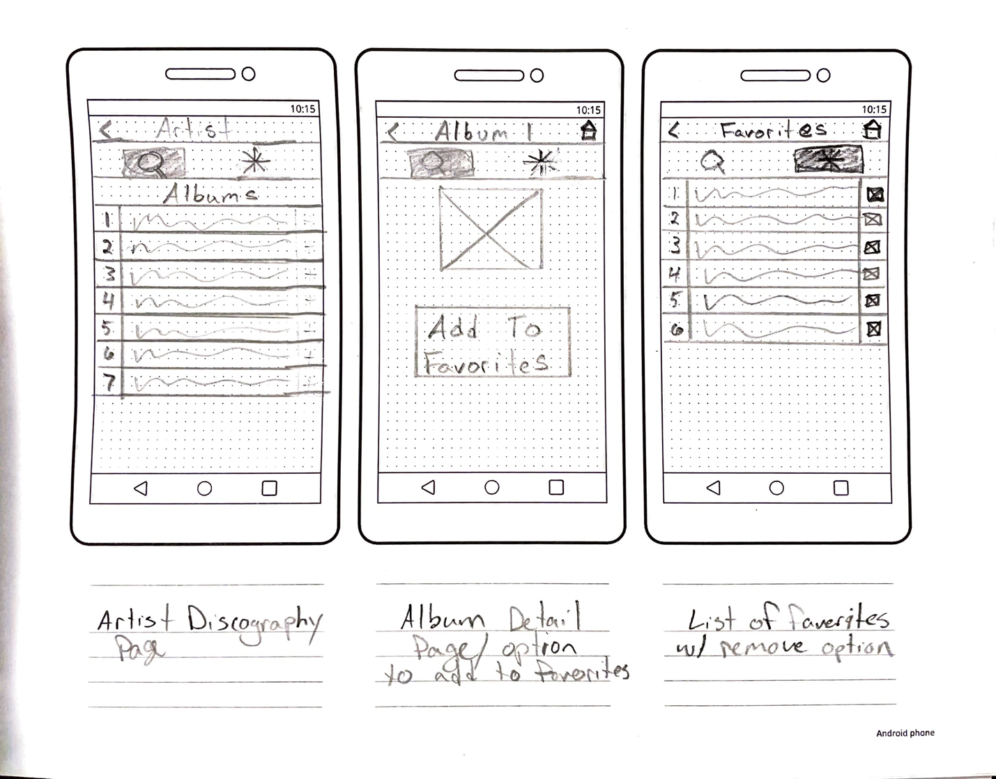

Figure 8. Davis, C. (2022). Lo-Fi Sketch 2. Self

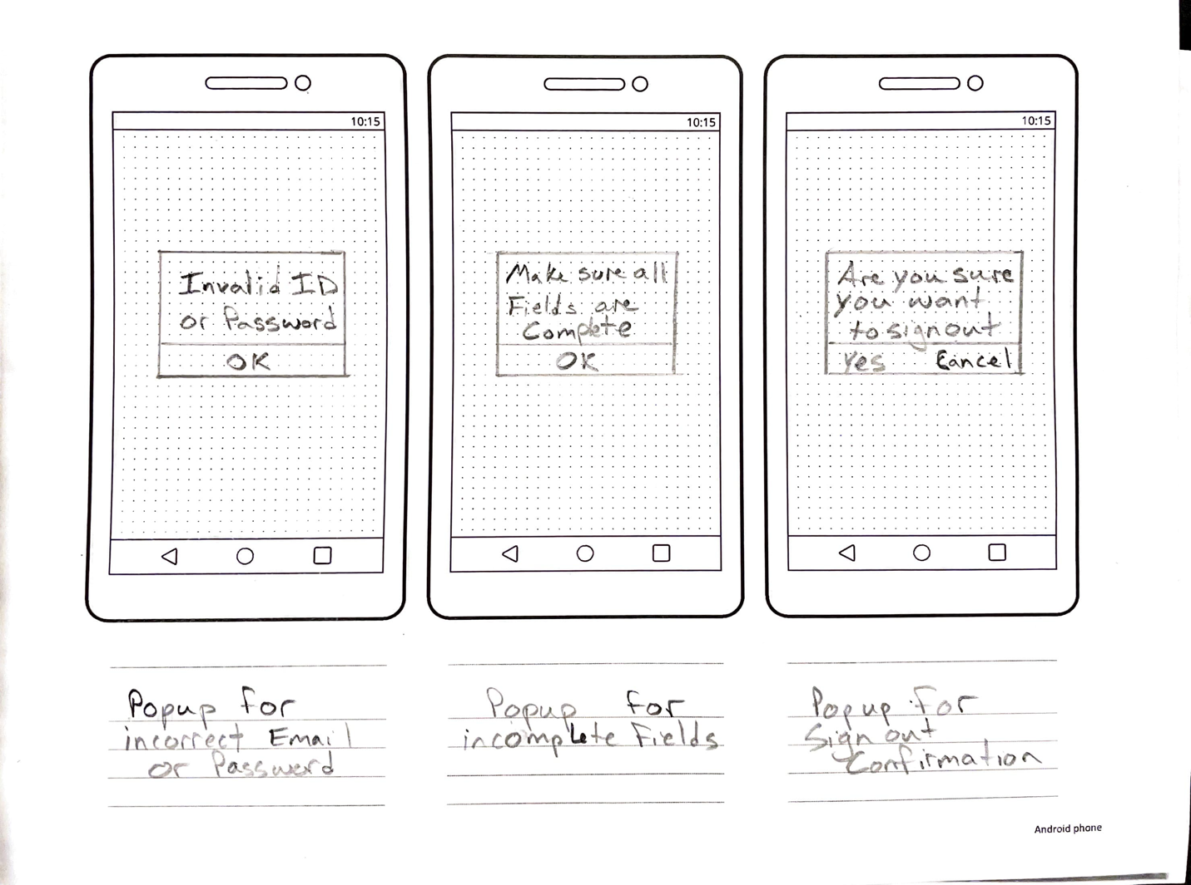

Figure 9. Davis, C. (2022). Lo-Fi Sketch 3. Self

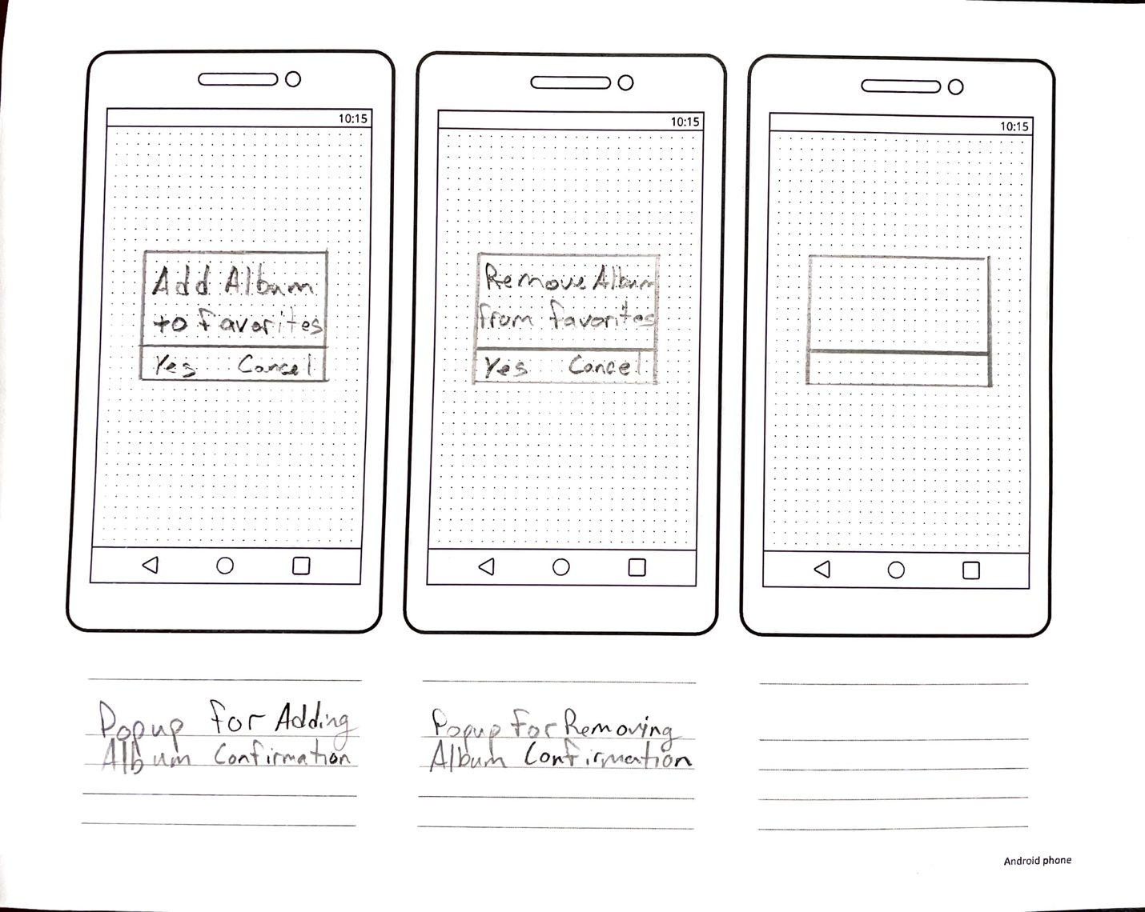

Figure 10. Davis, C. (2022). Lo-Fi Sketch 4. Self

## Low-Fidelity Digital Design

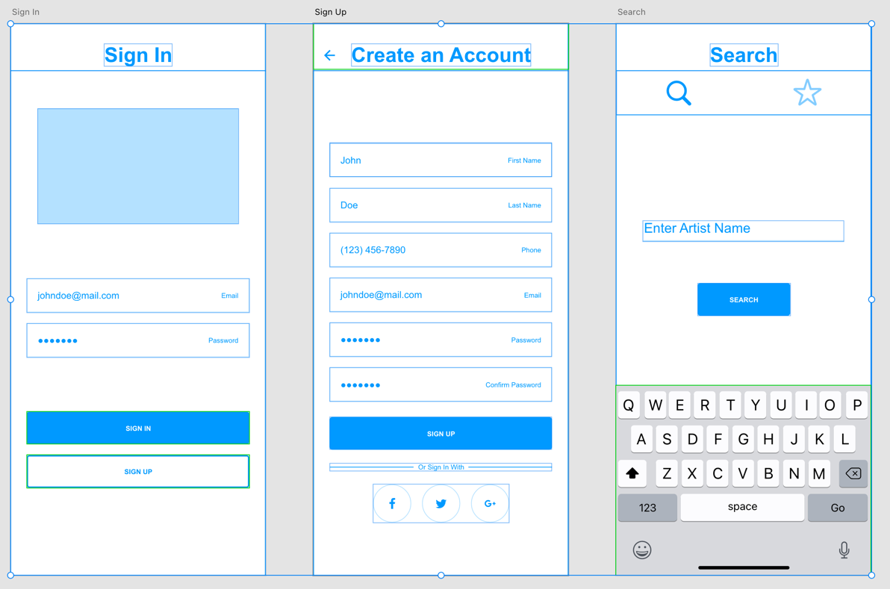

Figure 11. Davis, C. (2022). Lo-Fi Sign In, Sign Up & Search Feature. Self

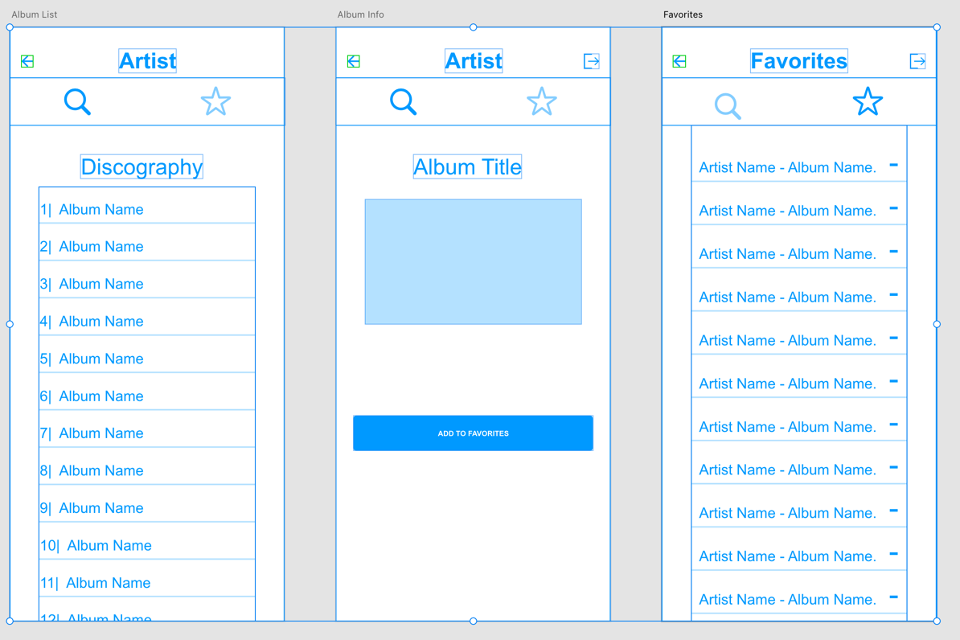

Figure 12. Davis, C. (2022). Album List, Album Cover, Favorites List. Self

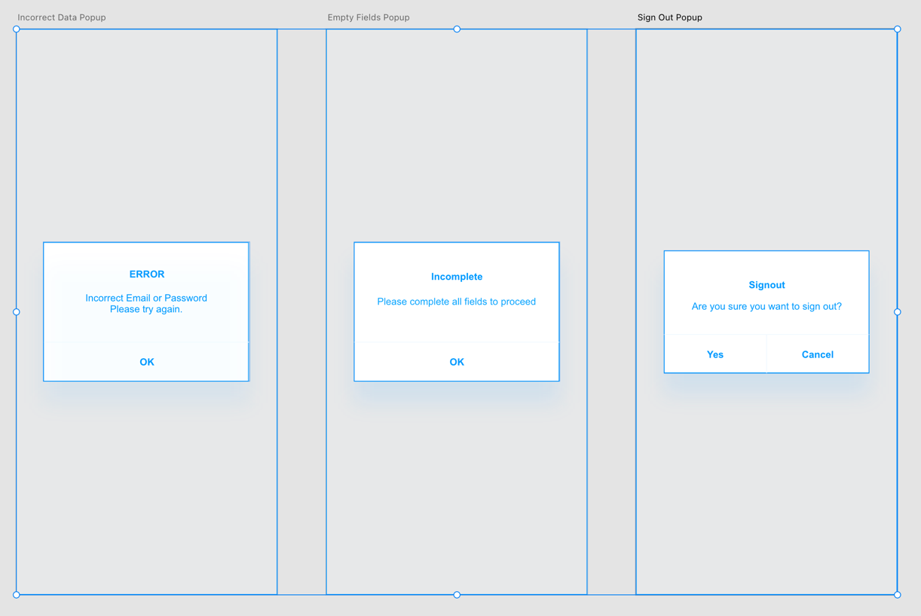

Figure 13. Davis, C. (2022). Lo-Fi Display Alerts 1. Self

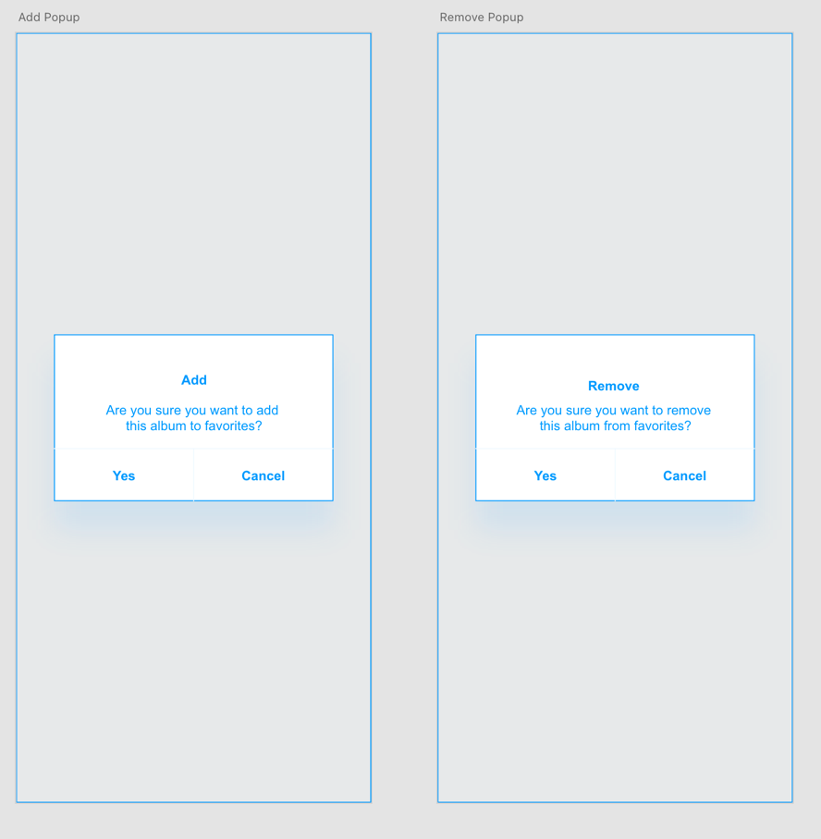

Figure 14. Davis, C. (2022). Lo-Fi Display Alerts 2. Self

## High-Fidelity Final Design

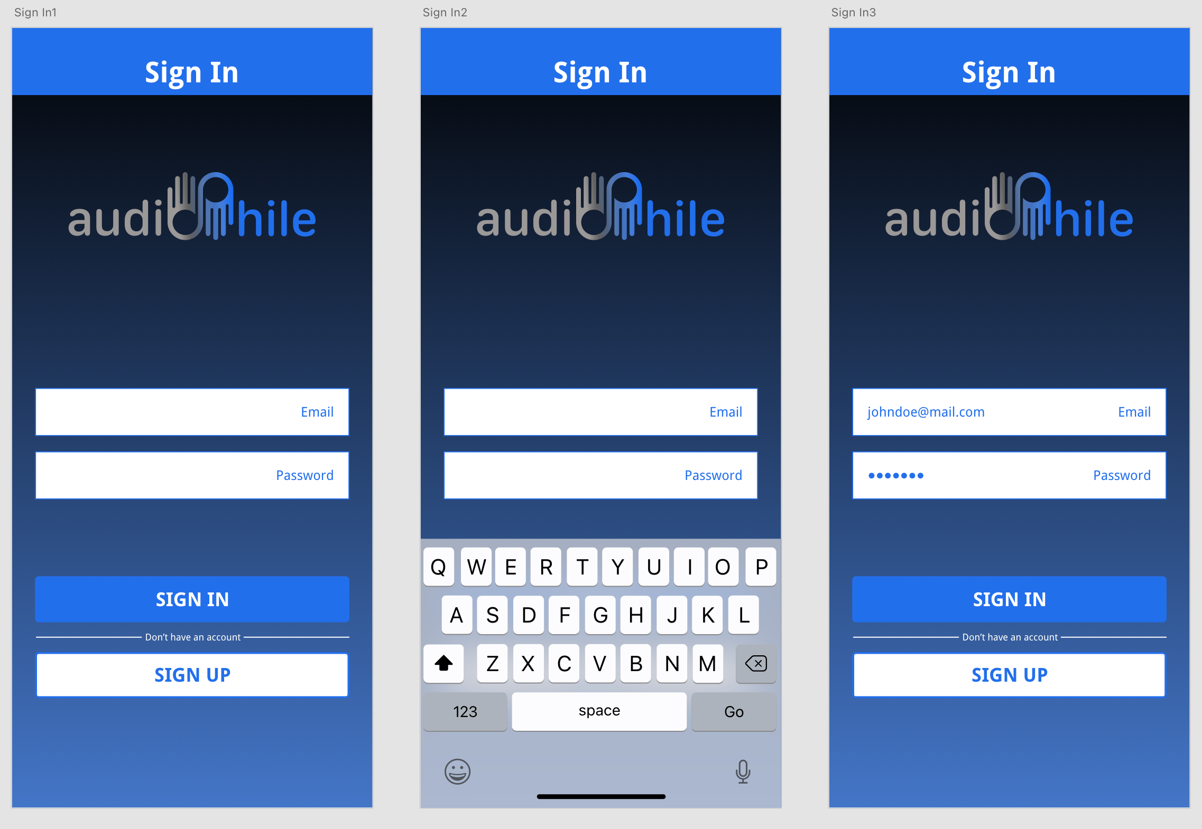

Figure 15. Davis, C. (2022). Hi-Fi Sign-In. Self

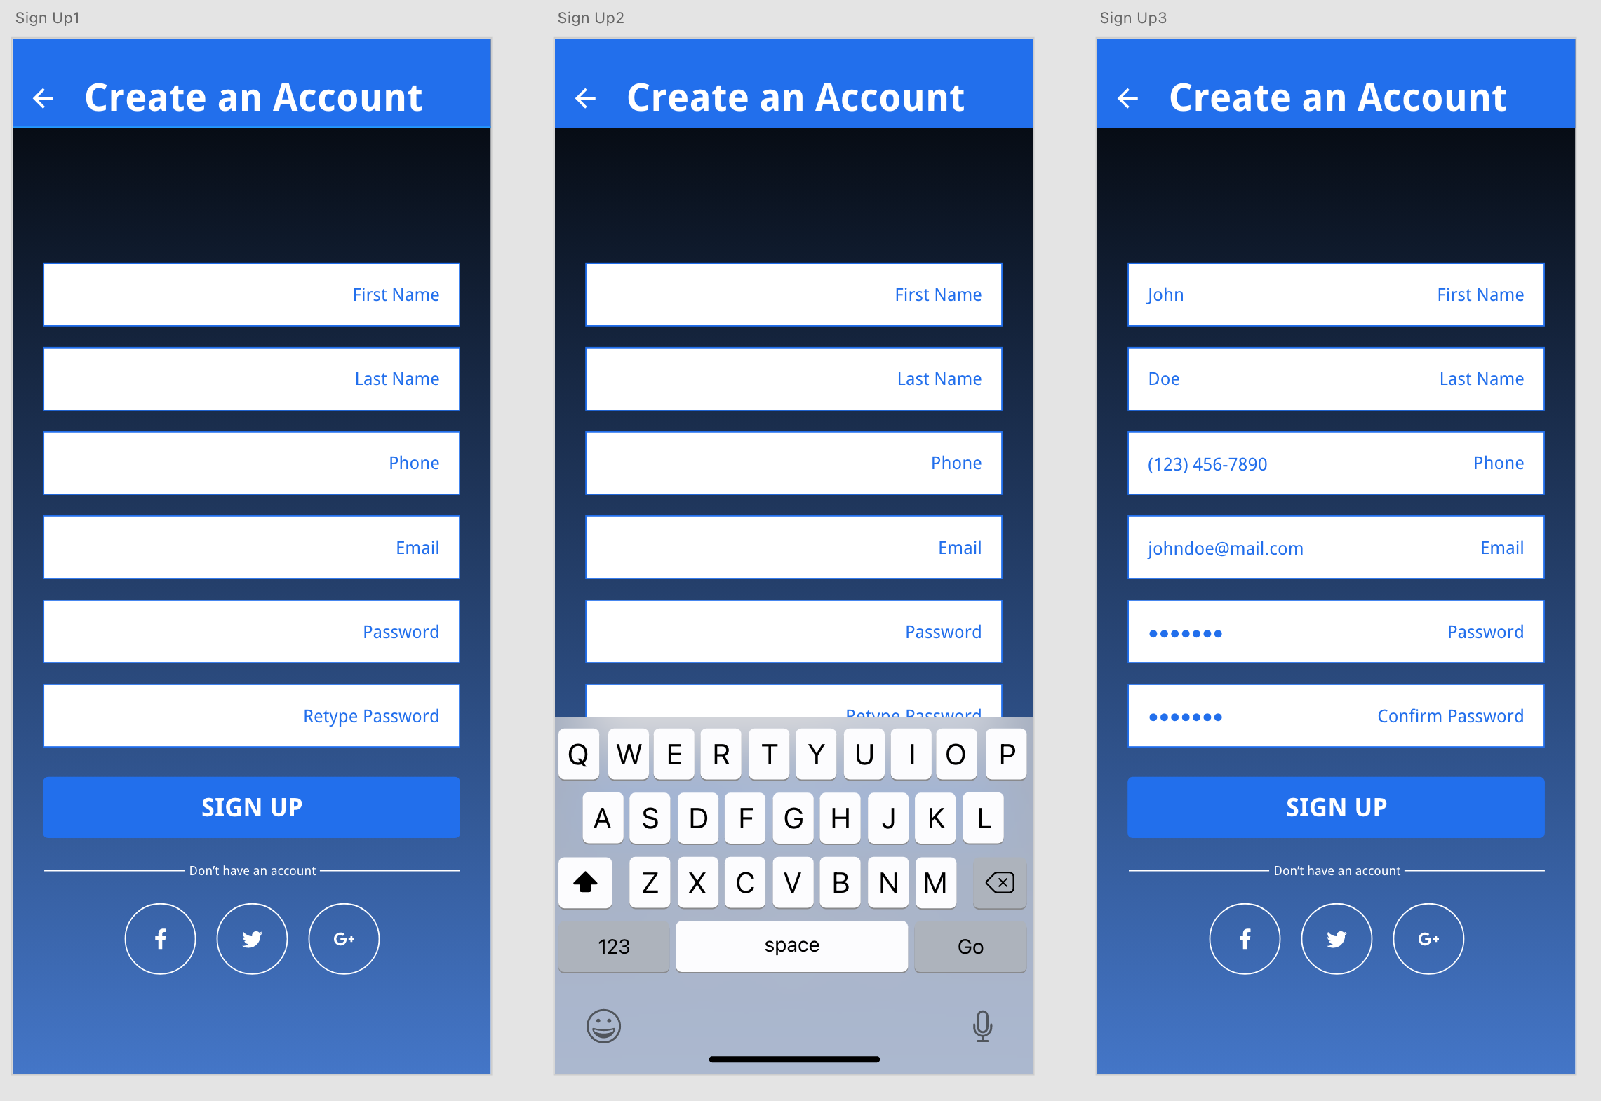

Figure 16. Davis, C. (2022). Hi-Fi Sign-Up. Self

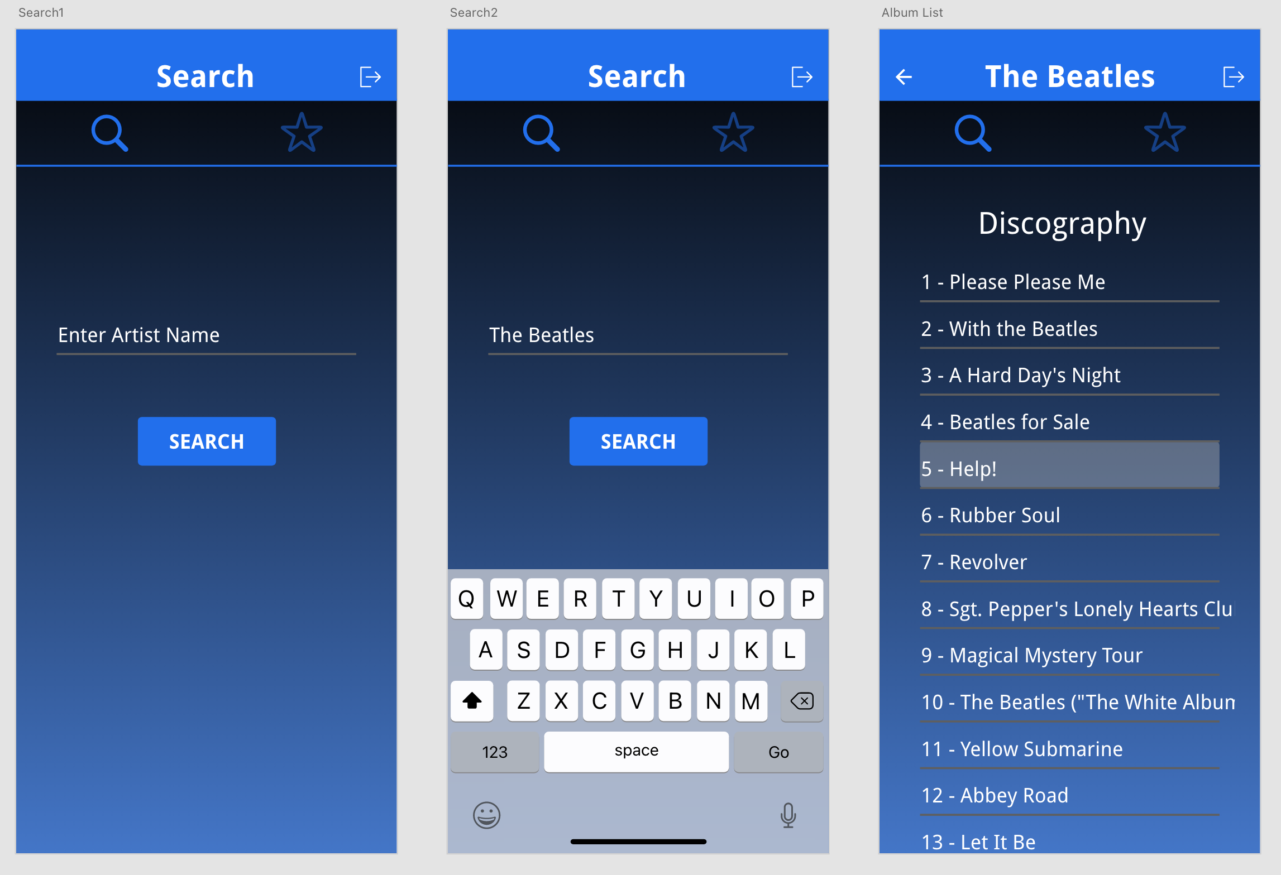

Figure 17. Davis, C. (2022). HI FI Search/ Album List. Self

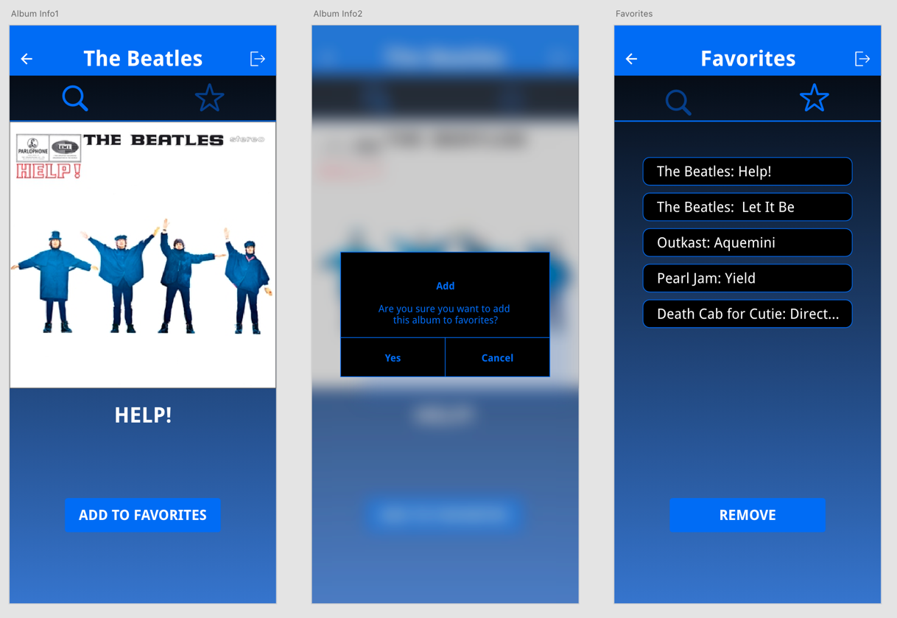

Figure 18. Davis, C. (2002). Hi Fi Album Info/ Favorites. Self

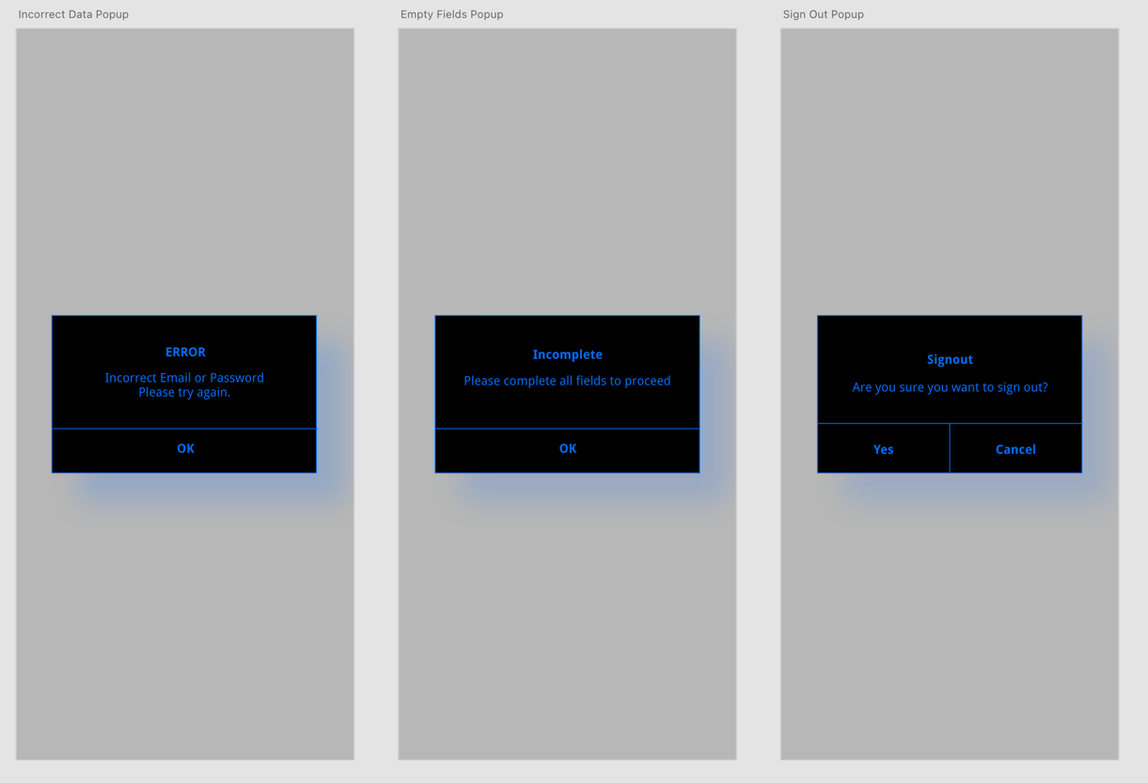

Figure 19. Davis, C. (2022). Hi-Fi Display Alerts 1. Self

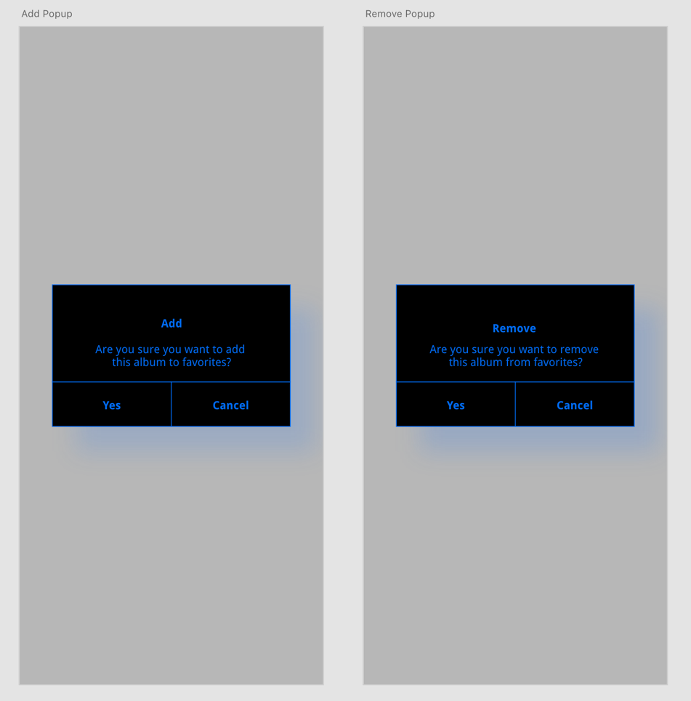

Figure 20. Davis, C. (2022). Hi-Fi Display Alerts 2. Self

**Usability Hub Data & Results (Low-Fidelity)**

## These are the links to the tests that were sent out to testers:

Test 1 - [Tester Info](https://app.usabilityhub.com/do/185e9b23b8ab/3edc)

Test 2 - [Color Palette](https://app.usabilityhub.com/do/4b486eb2c627/a62d)

Test 3 - [Interface](https://app.usabilityhub.com/do/6e83865d4cd6/dee4)

Test 4 - [Navigation](https://app.usabilityhub.com/do/f97f2f372514/3717)

Test 6 - [iOS or Android](https://app.usabilityhub.com/do/65d2f25bafdd/d845)

Test 7 - [Sign In / Sign Up](https://app.usabilityhub.com/do/6f27b53a7179/7463)

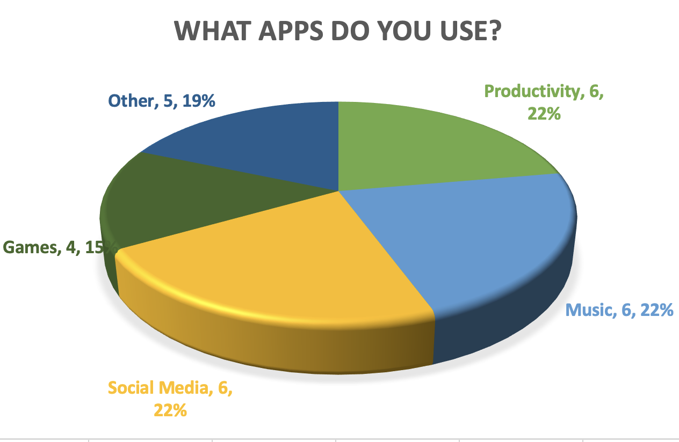

Figure 21. Davis, C. (2022). Lo-Fi Tester Info Pie Chart. Self

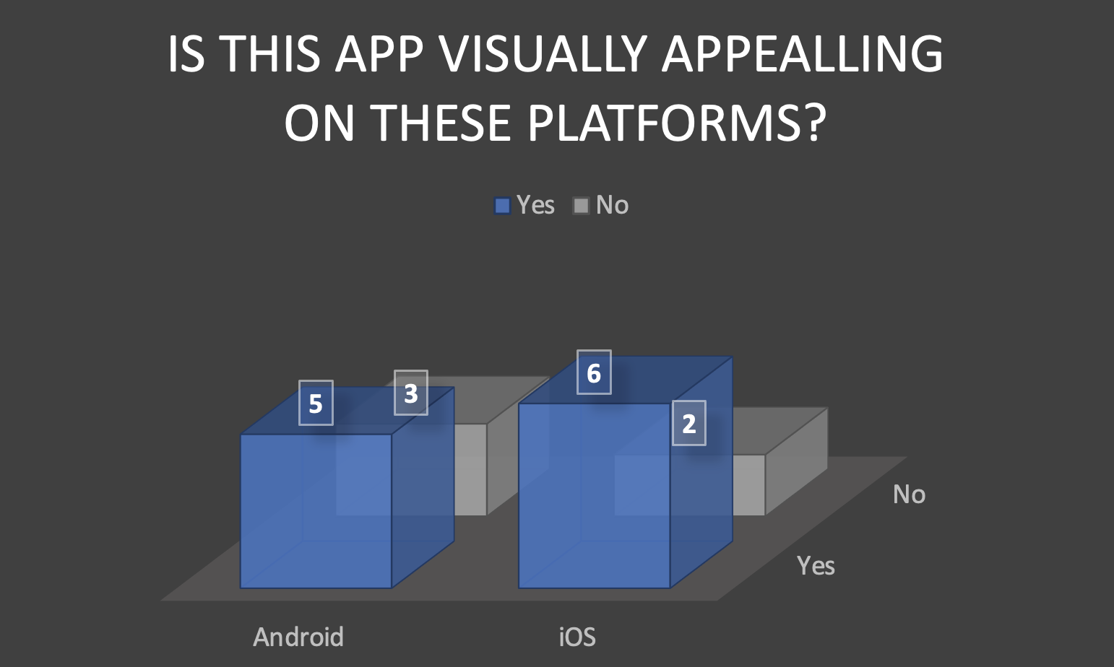

Figure 22. Davis, C. (2022). Lo-Fi App Preference Bar Chart. Self

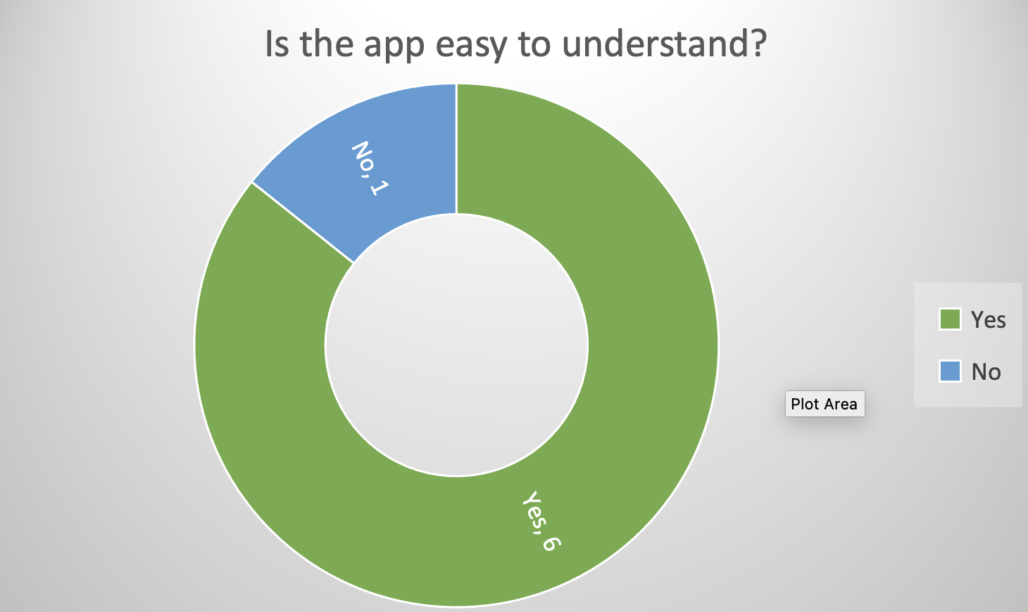

Figure 23. Davis, C. (2022). Lo-Fi Interface Donut Chart. Self

## Usability Hub Data & Results (High-Fidelity)

## These are the links to the tests that were sent out to testers:

Test 1 - [Tester Info](https://app.usabilityhub.com/do/719e4baa82fe/e179)

Test 2 - [Color Palette](https://app.usabilityhub.com/do/3c6d189b0f5f/c383)

Test 3 - [Interface](https://app.usabilityhub.com/do/570a35bc51ce/9181)

Test 4 - [Navigation](https://app.usabilityhub.com/do/c146b36035de/a415)

Test 6 - [iOS or Android](https://app.usabilityhub.com/do/7b927f60c918/5011)

Test 7 - [Sign In / Sign Up](https://app.usabilityhub.com/do/d772316a78c/da17)

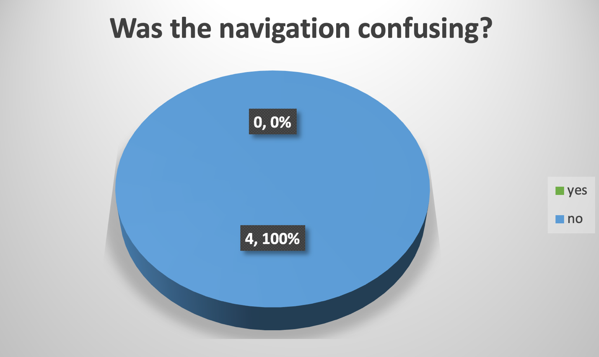

Figure 24. Davis, C. (2022). Hi-Fi Navigation Pie Chart. Self

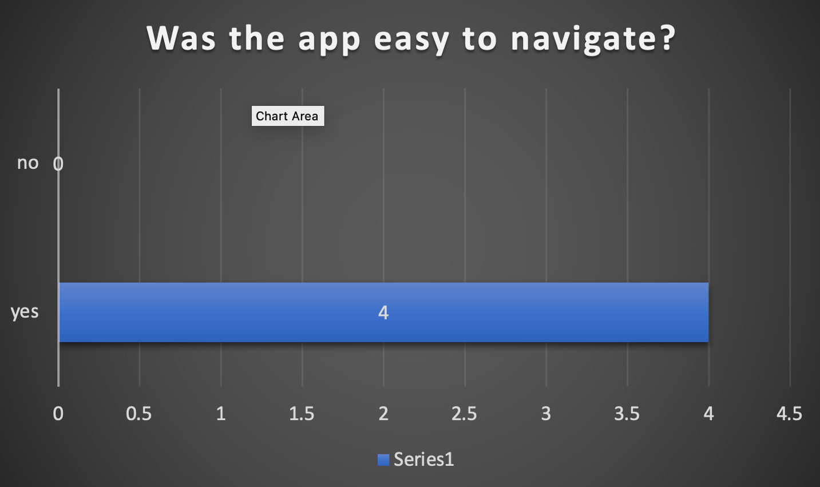

Figure 25. Davis, C. (2022). Hi-Fi navigation Line Graph. Self

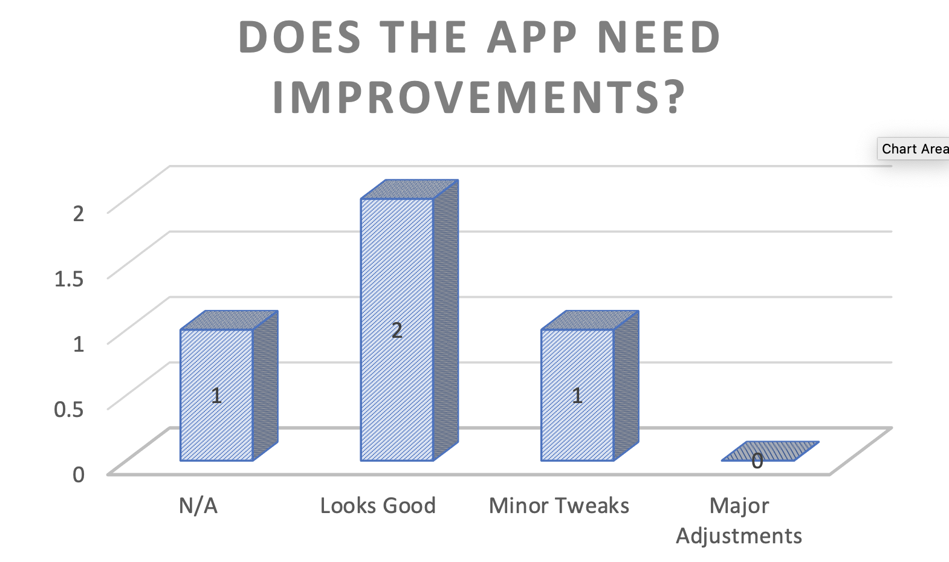

Figure 26. Davis, C. (2022). Hi-Fi Sign-In/Sign-up Bar Chart. Self

## Alpha Version

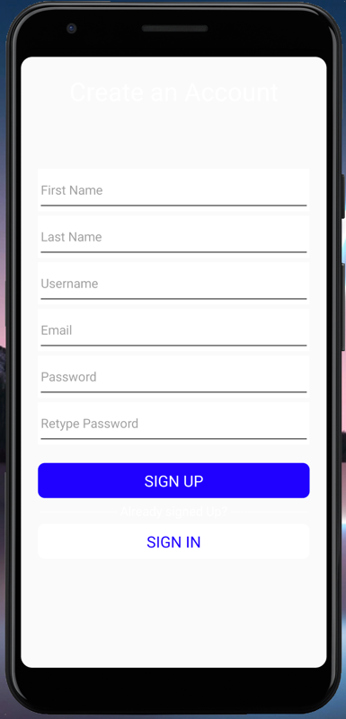 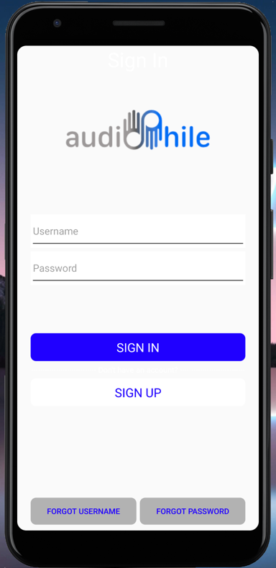 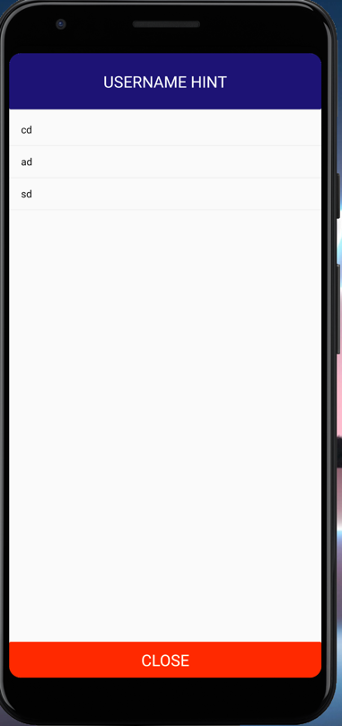

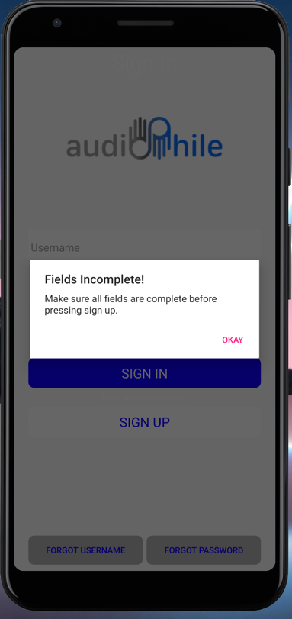 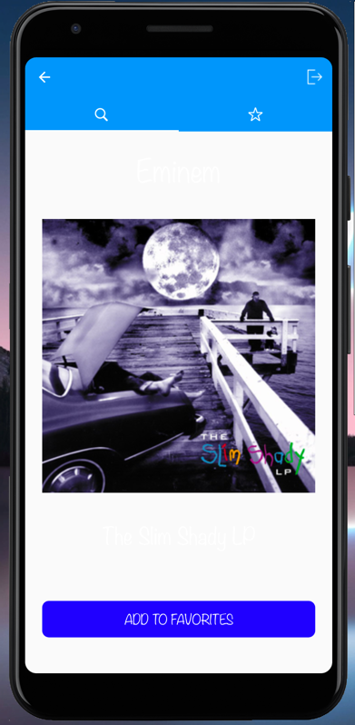

Figures 27-31. Davis, C. (2022). Lo-Fi Images of working Alpha. Self

[YouTube Link](https://youtu.be/HUjcHBGZmg4) to Alpha in action.

## Beta Version

## This section will have images of the Alpha version from the programming platform. They should be at least equal to the high fidelity version.

## There should also be a link to a YouTube version of the working app for viewers to review.

## Images References

* Figure 1. Torval, M. (n.d.). Collection of vinyl records on a shelf. Adobe Stock. <https://tinyurl.com/5n6svc4v>
* Figure 2. OutKast. (1996). *ATLiens* [CD]. LaFace Records. <https://en.wikipedia.org/wiki/ATLiens>
* Figure 3. (2022). Shazam iOS App & Icon. Apple App Store. https://apps.apple.com/us/app/shazam-music-discovery/id284993459
* Figure 4. (2022). Last.fm iOS App & Icon. Apple App Store. <https://apps.apple.com/us/app/last-fm/id1188681944>
* Davis, C. (2022). Adobe XD Content [Digital Images]. Self
* Davis, C. (2022). Lo-Fi Sketches [Hand Drawn Sketches]. Self